**Polar PiKVM Standard Manual**

Version: 1.2

Date: 5/9/24

Author: Nicholas Collier

**Connecting the Unit**

* Connect the unit to a Raspberry Pi 4 type power supply, or USB-C power supply that delivers 5.1v at 3a.
* Connect the ethernet port to the LAN network
* Connect HDMI in port to the HDMI video output port of the guest computer to be controlled.
* Connect the OTG USB-C port to a USB ports on the guest computer. A single ordinary USB-C cable with carry both mouse and keyboard connections.

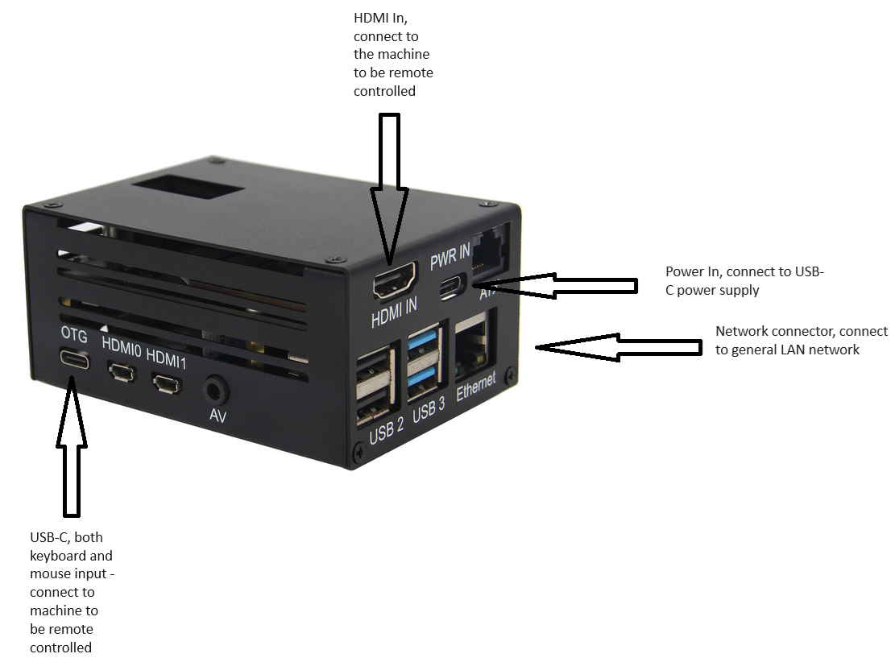

***Figure 1, PiKVM Ports***

* If desired, connect the optional computer motherboard adapter bord which controls IO commends between PiKVM and the guest computer including server power commands.

***Figure 2, Optional motherboard adapter board***

**Loggin In**

Connect the unit to the network and power on.

The unit will obtain an IP address via DHCP prior to any configuration having been carried out.

Find the DHCP assigned IP that the unit is using either by looking at the display panel on the top of the unit or finding out from the DHCP assignment information on the router/ DHCP server.

Put the IP address of the PiKVM into a browser to browse to the PiKVM’s web portal.

Use the default login: admin , admin

***Figure 3, PiKVM Login screen***

* Once logged in, you will be presented with three options: KVM mode, terminal mode or logout.

***Figure 4, PiKVM Main Menu***

* Click KVM in order remote control the guest computer on a hardware level.

***Figure 5, Example of PiKVM remote connection session***

* To enter terminal mode, click on terminal

***Figure 6, PiKVM terminal mode***

**Change to static IP**

* In the terminal, perform the following commands:

su - enter superuser mode, enter the password: root

rw - to put into read/ write mode

* Open the network configuration file:

nano /etc/systemd/network/eth0.network

* Perform required network changes:

Backup the existing configuration before making a change

An example is provided below:

[Match]

Name=eth0

[Network]

Address=192.168.2.2/24

Gateway=192.168.2.1

DNS=212.159.6.9

DNS=212.159.6.10

Save the configuration with ctlr-w, and enter ‘Y’ then enter.

**Exit su terminal mode:**

ro - put into read only mode

sudo reboot

**Accessing the device from the public internet**

In order to access the PiKVM from the public internet you will need to open up certain firewall access, and where NAT is used direct these ports via NAT / port redirection. To do this, you will need to use a router which can redirect a range of ports such as the “Open Ports” functionality in DrayTek routers.

In order to do this the following ports need to be given access/ redirected:

|  |  |  |
| --- | --- | --- |
| **Traffic** | **Protocol** | **Port(s)** |
| http | TCP | 80 |
| https | TCP | 443 |
| Misc | UDP | 25000 - 65535 |

**Reimaging the system software**

In some cases, applying a configuration incorrectly e.g. an IP configuration will result in the device becoming inaccessible. Reimaging may be the easiest way to resolve these situations. The PiKVM can be easily and quickly reimaged. Please use the following steps to reimage the device:

* Download the system image at https://polar-tech.co.uk/pikvm.html
* Download the Raspberry Pi imager programme from https://www.raspberrypi.com/software/ using the download links provided. You need to download the image based on the computer you are working on to install the image as opposed to the PiKVM device itself. If you are using Linux, there is no need to visit this download page as the RPi imager can be installed using the command “sudo apt install rpi-imager”.

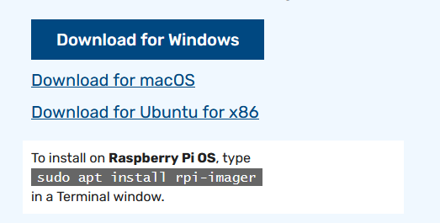

***Figure 6, Extract from Raspberry Pi imager download page***

* Unzip the system image file
* Locate the micro-SD card which inside the slot on the PiKVM marked "TF"
* Use a lump of blue tac to remove the micro-SD card by applying it to the micro-SD card and pulling it. Once you manage to eject the micro-SD card somewhat, you will be able to grab hold of it and remove it by hand.
* Insert the micro-SD card into a USB/ micro-SD card dongle and plug this into your computer
* Run the Raspberry Pi imager programme.
* Under Raspberry Pi Device, select “Raspberry Pi 4”.

***Figure 7, Raspberry Pi imager software***

* Under operating system, select “use custom” and a file selection dialogue box will pop up. Select the unzipped PiKVM image as the operating system file.

***Figure 8, Raspberry Pi imager software***

* Under operating system, select “use custom” and a file selection dialogue box will pop up. Select the unzipped PiKVM image as the operating system file.
* Under the storage selector, select the micro-SD card that you have made available to your computer.
* Once the settings have been made, please click “Next”, answer “No” to the question of whether to implement operating system customisations (which are not applicable to PiKVM), and answer “Yes” to the question that you understand that all data on the micro-SD card will be erased.
* The RPi imager takes around 5 minutes to image the micro-SD card, and another 5 minutes to perform a verification check.
* When starting the device for the first time, a build process will complete which takes several minutes before the device goes online. Please do not interrupt the device during this build process.

**FAQ:**

Q. I am getting a black screen when my PiKVM is connected to a working device.

A. First go to the screen icon in the top left corner in KVM mode in the PiKVM web interface. Toggle the video mode between “MJPEG/ HTTP” and “H.264/ WebRTC”. This may wake up the session even when set on the correct mode. Failing this, please check that your remote device is working, connected with a working cable and that screensaver/ blank screen modes have been disabled.

Q. I am getting screen glitches/ wrong resolution/ cropped screen when looking at the system BIOS of the remote computer or using Proxmox operating system.

A. This issue is common newer ASUS computers and can be solved using one the following methods:

* Enable Compatibility Support Module (CSM) in the remote computer’s BIOD which is usually under Boot options.
* Try connecting a DisplayPort (DP) monitor, or a dummy plug. If you remove the DP cable/adapter the bug will reappear.
* Try connecting the DP cable first, boot into the BIOS, disable the CSM and shutdown (do not restart) your PC. Then, boot into the BIOS and enable the CSM before shutting down your PC. Then connect the HDMI and turn your PC on again.
* PiKVM V3 has a hardware limit of 50Hz for 1080p mode, and this is a less common frequency than 60Hz. Therefore, on V3, the default mode is 720p. Some OS (like Proxmox) may not work well with 720p, so you can force 1080p resolution by default. Please refer to <https://docs.pikvm.org/edid/> .

Q. I am getting a browser security warning before I see the homepage of the PiKVM.

A. This is because no SSL certificate is installed, therefore the browser sees it as a security risk and alerts the user. You can install a self-signed certificate fairly easily but you need to register it against a domain name which has a DNS A record pointed at the PiKVM (including NAT rules) or the SLL certificate registration will fail. For more details, see <https://docs.pikvm.org/letsencrypt/#basic-setup> .

**References:**

PiKVM Handbook - https://docs.pikvm.org/v4/